Design and Development of Sodium-ion Batteries Based on Layered Transitional Metal Oxide Cathode Material

Zi-Feng Ma, Haiying Che , Yingying Xie , Hong Wang , Xiaozhen Liao
Shanghai Electrochemical Energy Devices Research Center, Department of Chemical Engineering, Shanghai Jiao Tong University, Shanghai, 200240, China

E-mail: zfma@sjtu.edu.cn

The Rechargeable lithium-ion batteries have been considered as a promising power source for the electric vehicles and the grid energy storage systems. However, lithium resources are limited and will restrict the huge applications of lithium-ion batteries. It is of great significance to develop eco-friendly sodium ion batteries which employ abundant sodium resources. Recently, we developed the large-scale synthesis route of NaNi_{1/3}Fe_{1/3}Mn_{1/3}O₂ (NFM) by using hydroxide co-precipitation combined with solid-state reaction, and the optimization reaction condition was studied by using in situ XRD. The metastable structure change of NaNi_{1/3}Fe_{1/3}Mn_{1/3}O₂ during electrochemical sodium ion intercalation which cycled at 0.1C rate between 2.0 to 4.0V, and 2.0 to 4.3V, were studied by using in operando TXM-XANES and XRD, and the thermal decomposition behavior and structure evolution of charged NaNi_{1/3}Fe_{1/3}Mn_{1/3}O₂ cathode material during heating process was measured by using in situ high-energy X-ray diffraction (HEXRD) technique.

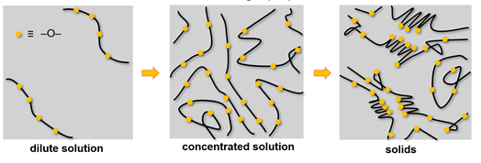

References:
[1] Y Xie, H. Wang, G. Xu et. al., Adv. Energy Mater., 2016,6(24) 1601306
[2] H Wang, X.-Z Liao, Y Yang et. al., J.Electrochem. Soc., 163 (2016) A565-A570.
[3] H Wang, X.-Z Liao, Y Xie, et. al., Energy Storage Science and Technology，2016, 5(1):65-68.
[4] H Wang, et. al., Electrochim. Acta, 113(2013)200-204
[5] D. Yang, et. al., J. Mater. Chem. A, 2(2014)6723-6726; 1(2013)13417-13421
[6] D. Yang, et. al., Chem. Commun., 50(2014)13377-13380; 51(2015) 8181- 8184.
[7] H.Che, S. Chen, Y. Xie, et al., Energy Environ. Sci., 10(2017) 1075-1101
[8] H.Che, J. Liu, H. Wang et al., Electrochem. Commun. 2017, 83(2017) 20-23.
[9] Y Yang, X.Yan, C. Ma, et al., J. Electrochem. Soc., 163 (2016) A2117-A2123
[10] L. Sun, Y. Xie, X,-Z. Liao, et al., Small，2018, 1701523

