免费穿梭巴士时刻表

Complimentary Shuttle Bus Schedule

Dear Guests,
During the Canton Fair period, we are pleased to offer complimentary shuttle bus between hotel to the China Import and Export Fair Complex (Pazhou Complex) for in-house guests. The detail schedule as following：

尊敬的贵宾：
酒店将在交易会期间为住店客人免费提供来往中国进出口商品交易
会展馆（琶洲展馆）的穿梭巴士。时刻表如下：

No.  班次 | Hotel - Pazhou Complex  酒店 - 琶洲展馆 | Pazhou Complex - Hotel  琶洲展馆 - 酒店
No.  班次 | Departure Time  出发时间 | Return Time  返回时间
1 | 08:30 | 16:00
2 | 08:50 | 16:30
3 | 09:10 | 17:00
4 | 09:30 | 17:30
5 | 10:00 | 18:00
6 | 10:30 | 18:30

Notice: The last day of every phase, the operation hour is from 09:00 to 12:00, please pay attention on the update schedule.

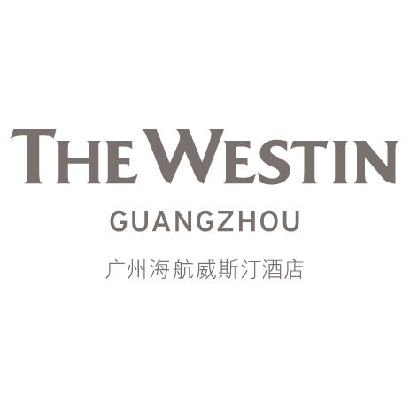
温馨提示: 每期最后一天琶洲展馆的营业时间为09:00-12:00，敬请留意酒店前一日的穿梭巴士时刻表。

